

Project Phase A

24-2-D-31

**Booking An Appointment**

**With Advance Payment**

**-NexTor-**

**Members Names :**

**♕ Hanan Madi – 314748211**

**♕ Rawan Sadeq – 315183723**

**Advisor’s name:**

**♕ Zakharia Frenkel**

**Table of contents**

Abstract……………………………………………………………………………….3

Introduction…………………………………………………………………………...4

Survey of platforms are currently available…………………………………………..7

Technological Survey………………………………………………………………..11

Expected Achievements……………………………………………………………..12

Criteria for Success………………………………………………………………….13

Engineering Process………………………………………………………………...14

Requirements………………………………………………………………………..16

Flow Chart…………………………………………………………………………..18

Diagrams…………………………………………………………………………….20

GUI………………………………………………………………………………….24

Testing……………………………………………………………………………….26

References…………………………………………………………………………...28

**Abstract**

Service based businesses face significant challenges in managing appointments, including high rates of no-shows, last-minute cancellations and cash flows issues due to delayed payments. Existing solutions, such as basic online booking systems and appointment scheduling apps, offer limited functionalities and fail to fully address these challenges. This project proposes the development of the "Booking an Appointment with Advance Payment" system, designed to streamline the appointment booking process, reduce no-shows, and ensure timely payment collection.

Our platform introduces standard advanced features such as automated reminders, flexible payment options, and the ability for customers to independently manage their appointments 24/7. It also provides business owners with tools to optimize customer management and improve service delivery. Additionally, the system enhances customer satisfaction by offering a seamless and transparent booking experience.

Our platform offers several unique advantages that set it apart from traditional booking systems. First, by requiring prepayment for appointments, cancellations are minimized, ensuring businesses maintain a steady revenue stream while customers stay committed to their appointments. Second, our platform has a mechanism, stimulating the continuous reception. This mechanism is based on a flexible changing of the preparing cost of the reception. Additionally, customers who can't attend an appointment have the option to transfer it to another client, preventing any loss of revenue or service for both parties. Lastly, the platform incorporates network marketing through an "a-friend-brings-a-friend" system, encouraging customer referrals and boosting business growth by allowing customers to invite friends to take over their appointments or book new ones.

To build the web application, we can use front-end tools like React for the interface, and back-end frameworks like Node.js. Key APIs such as Twilio for SMS, Stripe for payments, and Google Calendar for scheduling, along with databases like MongoDB.

**Introduction**

**Problem Statement:**

Service based businesses frequently encounter difficulties in managing appointments, including high rates of no-shows, last-minute cancellations, and cash-flow disruptions due to delayed payments. These issues lead to financial losses, inefficient use of resources, and a less-than-optimal customer experience. Without an effective way to ensure commitment and timely payment, businesses are left vulnerable to inconsistent revenue streams and operational inefficiencies.

**What are the existing solutions today?**

Current appointment scheduling systems and online booking apps offer basic functionalities such as scheduling, reminders, and notifications. However, these solutions often lack critical features needed to tackle the problems businesses face. They typically do not enforce prepayment, leaving businesses exposed to no-shows and last-minute cancellations. Furthermore, they offer limited options for flexible customer management, such as the ability to transfer appointments or handle unforeseen scheduling conflicts. This lack of functionality results in missed opportunities to optimize customer retention, prevent revenue loss, and encourage repeat business.

**Proposed Solution:**

We propose the Booking an Appointment with Advance Payment system, a platform designed to address these pain points by streamlining the appointment booking process and ensuring a smooth experience for both businesses and customers. Key features of our solution include:

* Prepayment for appointments to reduce cancellations and ensure steady cash flow.
* Automated reminders and flexible payment options to accommodate varying customer needs.
* Appointment transfer options that allow clients to transfer appointments to others, preventing revenue loss.
* A unique "a-friend-brings-a-friend" referral system to encourage customer referrals and boost business growth.

**What do we plan to do and why will it help solve the problem ?**

Our project contains the following features to solve the problems that we presented, also to be more developed :

1. A clear and well managed schedule.

2. Access from any device.

3. Obliges the client not to underestimate the time of the business owners.

4. Paying the advance guarantees the business owners (with a high probability) that the customer will come to the queue.

5. If the customer made an appointment and did not arrive, the business owner will not be harmed and the advance will not be returned to the customer.

6. The system automatically sends SMS reminders to customers before the appointment time.

7. The solution to waiting in line problems. A digital system for optimal customer management.

8. Managing the business with all capabilities on one platform in a friendly and convenient interface.

9. Computerized checkout and acceptance of all payment methods.

10. Option to divide the advance payment into more than one payment (there is a limit to the number of payments).

11. Sends a digital receipt to the customer who paid the advance.

12. Booking appointments from a link or from the platform.

13. Independent appointments by customers 24/7.

14. Convenient and efficient control over all business services.

15. Option to contact the business owners (customer service) or devlopers.

16. Option to change\cancel an appointment without a confernece, up to a certain time.

17. Registration on the waiting list if the appointment is busy or the customer wants an earlier appointment.

18. Sending a message to the customers on the waiting list that there is a customer who is ready to give up his appointment (still taking the appointment and ready to give it up).

19. The customer who wants to give up his appointment and doesn’t want to lose the advance, has the option of handing over his appointment to another customer by changing his status to "ready to give up the appointment" and whoever suits him this appointment can take it.

**Who are the stakeholders and how will the solution help them?**

Our project involves various stakeholders including business owners and customers. Business owners will benefit from increased customer satisfaction, streamlined operations, and enhanced visibility into performance through real-time analytics and improved decision-making. In Addition, customers will experience personalized service, easy access to support, and transparent appointment and payment policies. Overall, our solution will enhance efficiency, effectiveness, and customer-centric operations.

**Review of Document Structure:**

Project Overview: Introduces the Booking an Appointment with Advance Payment system, outlining its objectives and features.

Features: Explores the specific functionalities of the system, such as booking an appointment, pre-payment, appointment cancelling and transferring appointments.

Technologies: Details the technologies chosen for the project, explaining the rationale behind each selection.

Project Timeline: Outlines the planned phases of the project, from planning and design to testing and deployment.

Conclusion: Summarizes the project's goals and how it organizes the process of booking an appointment.

**Survey of platforms are currently available**

**Tor4You:**

There is a similar platform for scheduling appointments with advance payment, called Tor4You. This platform includes a many similar features like our platform:

* **Advanced Business Diary**: At the center of the system is the diary. Simple and easy to manage, it is accessible 24/7 from any computer. The smart diary adapts automatically to all the needs of your business and the ways in which you operate.
* **Customer SMS Reminders**: Automatically send messages to customers. SMS reminders reduce cancellations and no-shows by 90%. You can also send emails and SMS messages with appointment details for each booking, update, and cancellation.
* **Mobile App**: The 4You business app allows you to manage your business conveniently and simply from your mobile device. The application synchronizes in real-time with the business diary—every change made through the app is automatically updated in the diary, and every change made in the diary is updated in the app.
* **Customer-Made Appointments**: The system creates a dedicated website for your business, enabling customers to book appointments through your business's website, Facebook page, the system-generated website, or your business's mobile app.
* **Payments**: The system allows for collecting payments for services and issuing electronic tax invoices. Payments can be collected as an advance when the customer registers for the appointment or after the service is performed

**Some of the screenshot of this platform:**

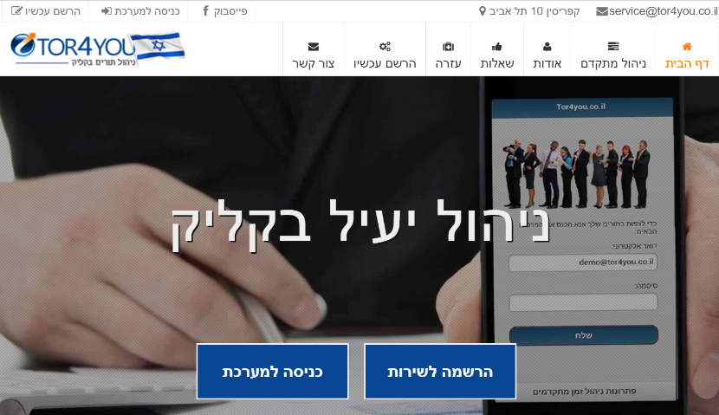Home page 🡪

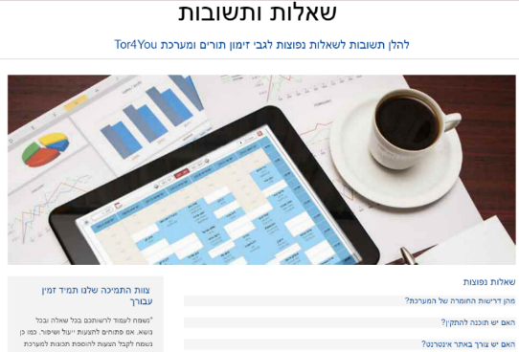

Questions and Answers page 🡪

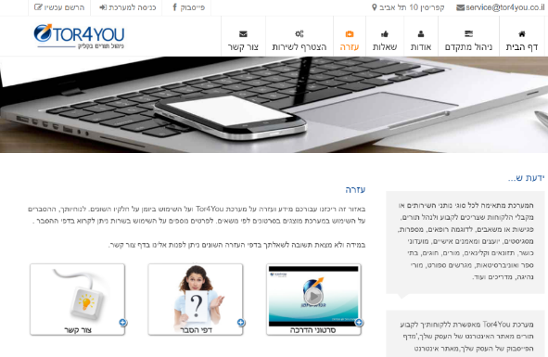Help page 🡪

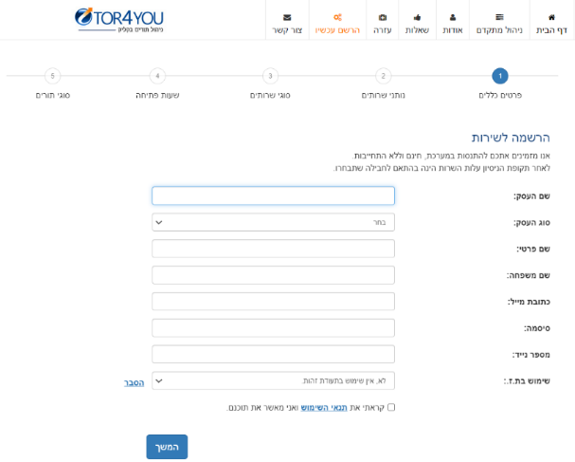Sign up for the service page 🡪

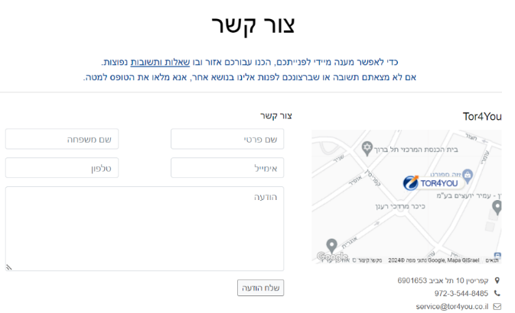Contact page 🡪

**Pink:**

A similar platform for scheduling appointments with advance payment. This platform includes a many similar features to our platform:

* **Scheduling appointments without holes in the calendar:** With our smart appointment scheduling system, customers can make appointments online, and calendars will fill up seamlessly. The application recommends the best available times for customers, ensuring there are no gaps in schedules. This means businesses can receive appointments 24/7.
* **Reminders on WhatsApp:** The application will take care of reminding the customers before the appointment and make sure that they do arrive with arrival certificates. WhatsApp reminders at no extra cost, no limit! It is well known that SMS messages do not receive attention, therefore it was important for us to provide you with an effective solution, which will prevent you from any inconveniences in front of the customers.
* **Accounting management:** production and management of all types of accounting documents for your business. Tax invoices, receipts, price offers, credits, etc. All documents are produced digitally, quickly, automatically and backed up in the cloud, even from the mobile, even when the customer’s order from you online, the system generates and sends the receipt automatically to WhatsApp.
* **Smart payment:** Your mobile becomes a billing interface, one click from the calendar to debit by credit, cash, Bit (no annual limit), Apple Pay and more... The app shows queues that have been paid and queues in debt so that you don't miss anything.
* **Advanced payment:** Get paid in advance for the service and enjoy an easier life. Get paid by credit or Bit by sending a payment link or in the application. A tax invoice/receipt will be generated automatically and you are left to deal with what is really important.

**Some of the screenshot of this platform:**

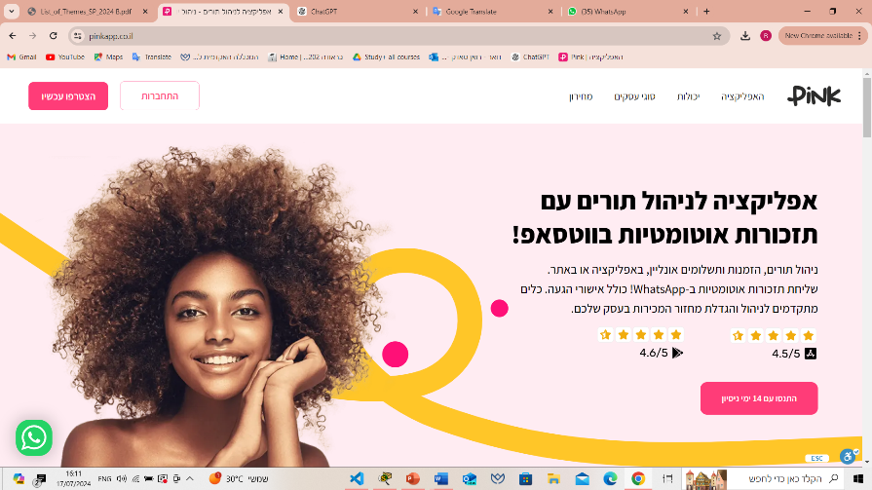Home Page🡪

Login page🡪 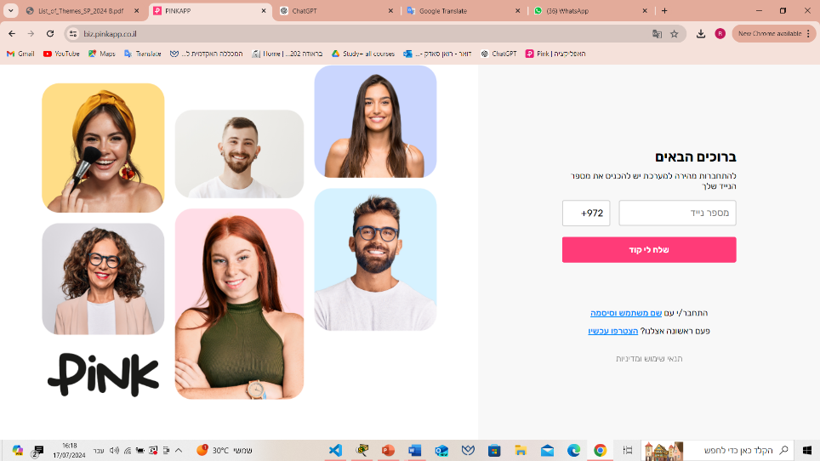

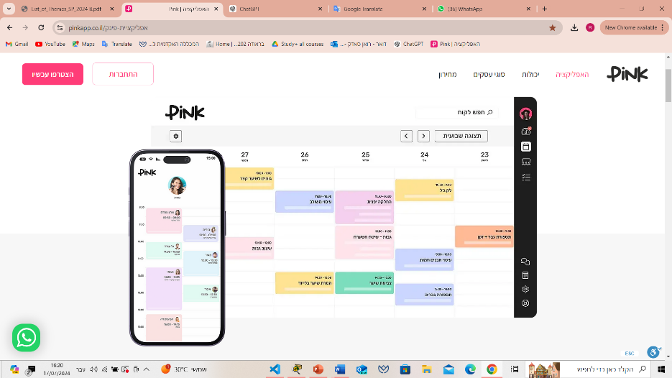booking page🡪

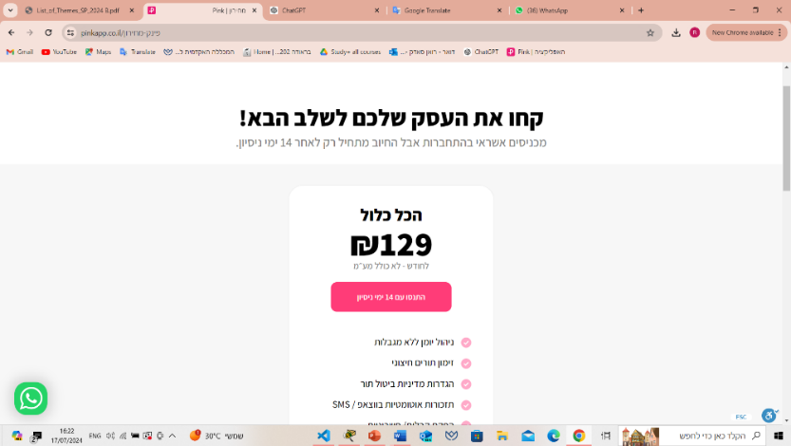Price list page🡪

**The difference between our platform and these platforms:**

Customers have the option to transfer appointments to others, helping to prevent any loss of revenue or service. A "friend-brings-a-friend" referral system encourages customers to invite friends to book new appointments, promoting growth through referrals. Additionally, customers can join a waiting list for earlier appointments, and the system automatically sends an SMS notification when a time slot becomes available.

**Technological Survey**

**Functionality that exists in every CRM system:**

1. Sign in/ sign up.
2. Customer Support and Service.
3. Payment system.
4. Booking an appointment.
5. Canceling an appointment.
6. Database to store and manage customer information.
7. Tools for creating and tracking tasks and activities related to customer interactions, such as meetings, and emails.
8. Security and Permissions.
9. Collaboration Tools.
10. Sending an appointment reminder message.

**Functionality that needs to be added to our platform:**

1. Advance payment.
2. Waiting list.
3. Option to change\cancel an appointment without a conference, up to a certain time.
4. The customer who wants to give up his appointment and doesn’t want to lose the advance, has the option of handing over his appointment to another customer by changing his status to "ready to give up the appointment" and whoever suits him this appointment can take it.

**Expected Achievements**

We have high expectations for our Booking an Appointment with Advance Payment system. We aim to expand the current resources available for booking appointments by providing an innovative and user-friendly platform.

In addition to the standard functionalities of Customer Relationship Management (CRM) programs, our platform offers unique features that enhance both service provider and customer experiences. These features include:

1. **Pre-Payment Requirements and Appointment Cancellation Policies** : Service providers can set specific requirements for pre-payments when customers book services. They can also establish conditions under which appointments can be cancelled (with no, or partial return of the pre-payment). This provides clarity and security for both parties regarding financial transactions.
2. **Customer Replacement Option** : If a customer needs to cancel an appointment, the platform allows them to find someone else to take their place. This ensures that the service provider doesn't lose business and the customer has the opportunity to save their pre-payment by facilitating a replacement. Additionally, there is a status button that indicates whether the customer is currently searching for someone to take their appointment. This provides transparency and helps expedite the replacement process.
3. **Chain Trading Support** : The platform will support chain trading, which refers to a system where transactions or services are linked in a sequence. This can involve multiple parties and can enhance the flexibility and efficiency of trading services within the platform.
4. **Feedback And Reviews** : In order to enhance the service, the system will include a feedback and review mechanism where customers can provide input on their scheduling and the service they receive. This feedback will be used to identify areas for improvement and drive ongoing enhancements to the system.

By detailing these features, the platform not only covers the basics of CRM but also introduces advanced functionalities that cater to modern business needs and customer expectations.

**Criteria for Success**

**1. Reduction of No-Shows and Cancellations:** The system effectively reduces no-shows and cancellations through advance payment requirements and automated reminders.

**2. User Satisfaction:** Customers find the platform intuitive and easy to use, with features like flexible appointment management, seamless payments, and the ability to transfer appointments.

**3. Business Growth through Referrals:** The network marketing "a-friend-brings-a-friend" feature generates customer referrals, boosting overall business growth.

**4. Seamless Integration with External Services:** APIs like Twilio, Stripe, and Google Calendar are successfully integrated, providing reliable communication, payment processing, and scheduling.

**5. Optimized Business Operations:** Business owners can manage appointments, track payments, and analyze customer data more efficiently, improving overall service delivery.

**6. 24/7 Appointment Management:** Customers can independently book, reschedule, or cancel appointments at any time, leading to higher user engagement and convenience.

**7. Scalability and Performance:** The platform is scalable and performs well under increasing loads, supporting multiple businesses and users without significant slowdowns or crashes.

**8. Secure Payment Processing:** All payment transactions are secure, with encryption and compliance with industry standards to protect sensitive customer information.

**9. Customizable Business Settings:** Business owners can easily customize settings such as pricing, appointment durations, and cancellation policies, allowing the platform to adapt to various business models.

**10. Real-Time Notifications:** Automated real-time notifications, including SMS reminders, ensure that customers are informed of upcoming appointments or changes.

**11. Effective Customer Support:** The platform includes robust customer support features, such as chatbots or live support, ensuring timely assistance for users facing issues.

**Engineering Process**

The engineering process for developing the "Booking an Appointment with Advance Payment" platform can be broken down into several key stages, each addressing both technical and business needs:

**1. Research**

**Problem Space:** Investigated the key challenges service-based businesses face, such as high rates of no-shows, last-minute cancellations, and cash flow issues due to delayed payments. Existing booking systems were reviewed to identify gaps in their functionalities and areas for improvement, especially in the realm of payment and customer management.

**Market Needs:** Identified specific needs of businesses for a solution that reduces financial risks, encourages customer commitment, and streamlines appointment management. Features like prepayment, appointment transfer, and network marketing ("a-friend-brings-a-friend") were deemed critical for business success and customer retention.

**Technological Solutions:** Researched potential technologies for implementation, focusing on scalability, flexibility, and ease of use. React was identified as the preferred front-end tool, with Node.js as the back-end framework, MongoDB for databases, and APIs like Twilio, Stripe, and Google Calendar for communication, payment, and scheduling integration, respectively.

**2. Methodology and Development Process**

**Requirement Gathering:** Gathered business and user requirements to build the foundation for the platform. Defined key functionalities such as prepayment for appointments, automated reminders, appointment transfer capabilities, and customer management tools.

**System Design & Architecture:** Designed a system architecture that utilizes:

Front-End: React to provide an interactive user experience, allowing customers to manage bookings, transfers, and payments effortlessly.

Back-End: Node.js to manage the server-side logic, handle API integrations, and maintain data integrity through MongoDB.

APIs: Twilio for automated reminders via SMS, Stripe for secure payment processing, and Google Calendar for seamless scheduling.

**Feature Prioritization:** Prioritized core functionalities prepayment, booking, and reminders while planning for advanced features like appointment transfers and network marketing to be introduced in later iterations.

**UI Design:** Focused on making the platform intuitive for both businesses and customers, emphasizing device compatibility and accessibility. Designed a clear booking flow, appointment management tools, and payment interface to enhance user experience.

**Development:** Split development into front-end, back-end, and API integration workstreams:

Front-End: Built interactive, responsive interfaces for booking, payments, and user management using React.

Back-End:Implemented business logic, data handling, and integration with external services through Node.js and MongoDB.

APIs: Integrated third-party services like Stripe for payment processing, Twilio for SMS notifications, and Google Calendar for scheduling synchronization.

**Testing & Quality Assurance:** Conducted functional, integration, and user acceptance testing to ensure all features work as expected. Special attention was paid to payment processing, scheduling, and appointment transfer workflows.

**3. Constraints**

**Budget and Resources:** Limited budget and resources mean that not all features can be developed simultaneously, necessitating careful prioritization. Early versions will focus on core features, with advanced features like appointment transfer and network marketing rolled out later.

**Security:** Handling sensitive customer data, especially payment information, adds significant complexity to the development process.

**Scalability:** The platform must be designed to scale as the user base grows, particularly when handling real-time appointment transfers and notifications. Planning for scalability is critical but challenging with limited initial resources.

**Third-Party API Dependence:** The platform relies on external APIs (e.g., Stripe, Twilio, Google Calendar) for key functionalities. Any downtime or changes in these services can impact the platform’s reliability, requiring fallback mechanisms and careful API integration.

**Diverse Business Models:** The platform must be flexible enough to accommodate different service-based businesses with unique appointment and payment workflows, without adding excessive complexity to the system.

**Requirements**

**Functional:**

|  |  |
| --- | --- |
| **1** | **The system allows users (business owners/customers) to create an account by providing their name, email address, contact information, and password.** |
| **2** | **The system allows users (business owners/customers) to manage their profiles, including updating personal information, notification preferences and change the password.** |
| **3** | **The system allows registered users (business owners/customers) to log in to their accounts using their email address and password.** |
| **4** | **The system allows users (business owners) to add their business information (business name, phone number, email address, type of the service, payment policy, etc.).** |
| **5** | **The system allows to display all the businesses that works on the website.** |
| **6** | **The system allows users (customers) to choose the service that they want.** |
| **7** | **The system allows to display the calendar.** |
| **8** | **The system allows to display the available appointments in the calendar.** |
| **9** | **The system allows users (customers) to choose the appropriate date of the appointment.** |
| **10** | **The system allows users (customers) to choose the appropriate time of the appointment.** |
| **11** | **The system allows users (customers) to register on the waiting list if they want an earlier appointment.** |
| **12** | **The system allows to send to users (customers) a SMS if an appointment has become available.** |
| **13** | **The system sets a specific time to the user (customer) to books the appointment that he received via SMS.** |
| **14** | **The system allows to display the information of payment methods for the advance.** |
| **15** | **The system allows payment verification and notify users of successful or failed transactions.** |
| **16** | **The system allows to send to users (customers) a SMS of the appointment information (receipt).** |
| **17** | **The system allows to send to users (customers) a reminder SMS of the appointment.** |
| **18** | **The system allows to display the status of the appointment (the appointment is busy / ready to give up the appointment).** |
| **19** | **The system allows users (customers) to give up their appointment.** |
| **20** | **The system allows users (customers) to transfer their appointment.** |
| **21** | **The system doesn’t allow to return the advance if the appointment date has passed and the customer is still with “ready to give up the appointment” status.** |
| **22** | **The system doesn’t allow to return the advance if the customer missed his appointment.** |
| **23** | **The system allows to returns the advance to the customer if another customer took the appointment and paid the advance.** |
| **24** | **The system allows users (customers) to bring another user (a-friend-brings-a-friend).** |
| **25** | **The system allows users to contact with business owners or the developers.** |

**Non-functional:**

|  |  |
| --- | --- |
| **1** | **The system should be fast and responsive when users log in, book appointments, or manage their profiles.** |
| **2** | **The system should be available and accessible to users at all times, with minimal downtime.** |
| **3** | **The website should support secure payment processing through various payment methods (credit card, PayPal).** |
| **4** | **The platform should be easy for users to navigate and complete tasks efficiently, with a design accessible to all, including those with disabilities.** |
| **5** | **The system should function consistently without errors, and notifications like SMS alerts should be sent promptly.** |
| **6** | **The platform should follow all necessary legal and regulatory requirements for data privacy and security.** |
| **7** | **The system should be effective to avoid performance issues, even when many users are using it at once.** |
| **8** | **Information such as appointments should always be accurate and reflect the latest updates in real time.** |
| **9** | **Users should have access to customer support, and critical issues should be addressed in a timely manner.** |
| **10** | **The system should support multiple languages and currencies, allowing users from different regions to use the platform effectively.** |
| **11** | **Date, time, and currency formats should adapt based on the user’s location and preferences.** |
| **12** | **The system should be adaptable to different types of businesses.** |

**Flow Chart-The process:**

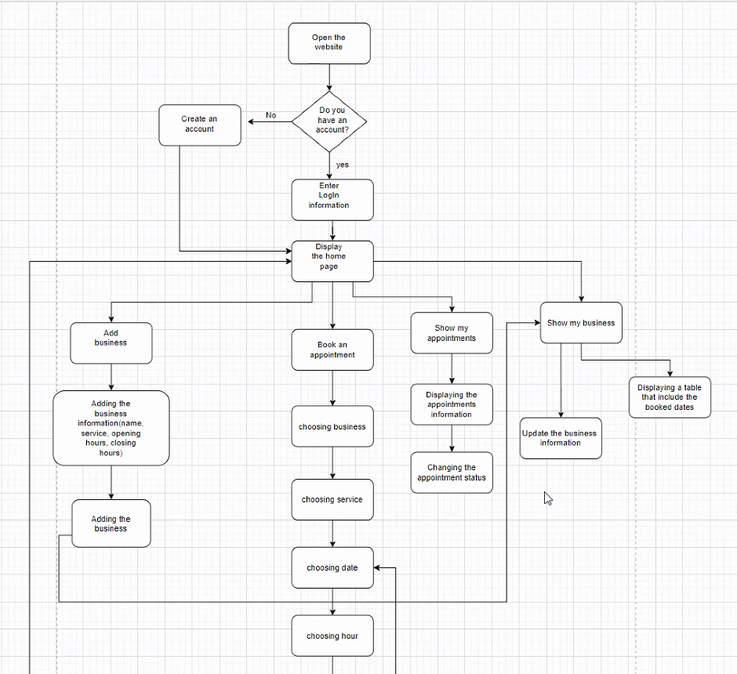

The flowchart outlines a user journey for managing business information and booking appointments on our platform. The process begins with the user visiting the website and determining whether they have an existing account. If they don’t, they are prompted to create one. If they do have an account, they can log in and be directed to the homepage. Once on the homepage, the user can perform several actions, including adding business details, booking appointments, viewing their appointments, or managing their business information.

When adding a business, the user provides details such as the business name, services offered, and operating hours. After submitting this information, the business is successfully added to the system. To book an appointment, the user selects a business, chooses the desired service, and picks a date and time. The system then checks if the selected time slot is available. If it is, the user proceeds to make an advance payment. If the payment is successful, a confirmation message is sent. If the slot is unavailable, the user is given the option to join a waiting list.

Additionally, the user can view their upcoming appointments and change the status of any booking if necessary. Through the "Show My Business" option, the user can update business information and review a table displaying all booked appointments. This entire process provides a structured and efficient way to manage appointments and business details online.

**Diagrams**

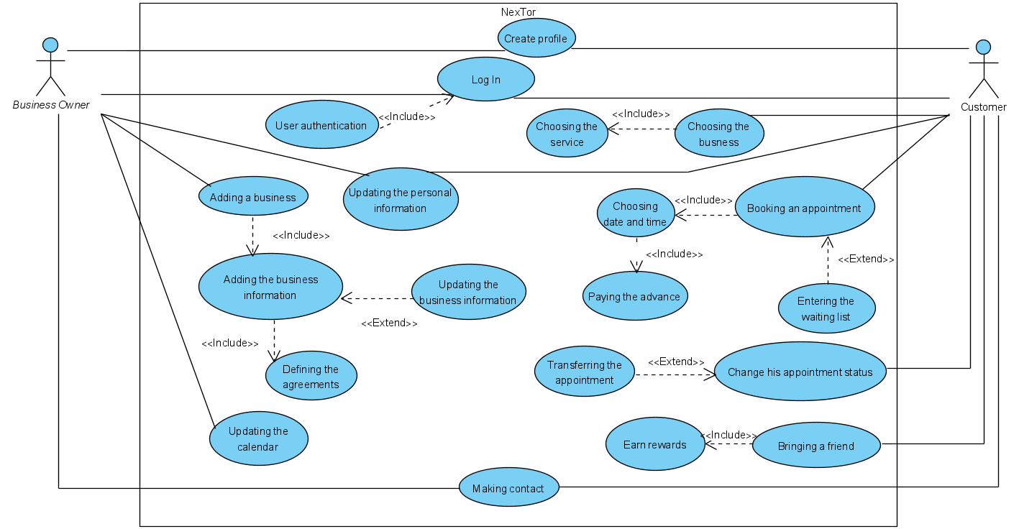**Use Case Diagram:**

**Create profile:** Both business owners and customers can create a profile on the system. this is the entry point into the system for new users.

**Log In:** Existing users (customers and business owners) log into the system to access its features.

**User authentication:** This is a system function that verifies user credentials during login. It extends both the customer login and business owner login.

**Adding a business:** The business owners can add their business to the system.

**Adding the business information:** The business owner provides detailed information about their business. for example, business name, phone number, email address, type of the service, payment policy, working hours, etc. ("Adding a Business" process include the "Adding the Business Information" process).

**Updating the business information:** The business owner can update or modify the business details. For example, updating the working hours.

**Defining rules:** The business owner defines the rules. For example, the amount of the advance, duration of the service, the reward that the customer receives when he brings a friend. ("Updating the business information" process include the " Defining rules" process).

**Updating the calendar:** The business owner updates their available schedule. Which means that he can add the available dates and hours.

**Updating the personal information:** Users (business owners and customers) can update their personal details.

**Choosing the business:** The customer chooses a business to book an appointment.

**Choosing the service:** The customer selects a service offered by the business.("Choosing the business" process include the " Choosing the service" process).

**Booking an appointment:** The customer can book an appointment.

**Choosing date and time:** As part of " Booking an appointment", the customer selects a preferred date and time.

**Entering the waiting list:** If the date slot is unavailable or the customer wants an aerial appointment, he can join a waiting list.

**Paying the advance:** As part of " Booking an appointment", the customermakes an advance payment for the appointment.

**Change his appointment status:** The customer can modify the status of their appointment (the appointment is busy / ready to give up the appointment).

**Transferring the appointment:** The customer may transfer the booked appointment to another customer.

**Bringing a friend:** The customercan tell his friend about the website to join it, and if he joins then the customer earns money.

**Making contact:** The business owners and customers can communicate with each other.

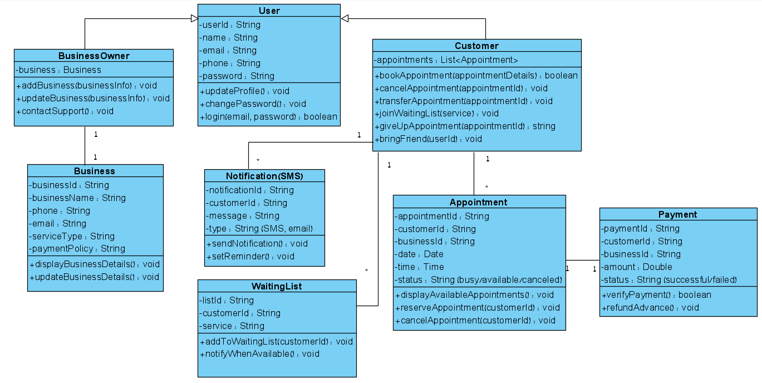**Class** **Diagram:**

**User:** Represents a general user of the system (either a customer or a business owner) and contains common attributes like name, email, phone, and password.

**Business Owner:** A subclass of "User", this class manages business-related functionalities such as adding or updating their business information.

**Customer:** A subclass of "User", representing a customer who books appointments, manages reservations, and interacts with businesses.

**Business:** Stores details about a business, including its name, contact information, services, and payment policies, managed by a Business Owner.

**Appointment:** Represents an appointment booked by a customer with a business, holding details such as date, time, and status.

**Notification (SMS):** Handles sending notifications (SMS or email) to customers, such as appointment reminders or availability alerts.

**Payment:** Manages payment transactions for booked appointments, including verifying payments and handling refunds.

**Waiting List:** Allows customers to join a waiting list for earlier appointments and notifies them when a slot becomes available.

**Relationships:**

1. **Customer → Appointment** (One-to-many):

A customer can have many appointments, and each appointment is linked to a single customer.

1. **Business Owner → Business** (One-to-one):

A business owner manages one business, and a business is owned by one owner.

1. **Customer → Waiting List** (One-to-many):

A customer can join many waiting lists for a service, and each waiting list is linked to a single customer.

1. **Appointment → Payment** (One-to-one):

Each appointment has one associated payment (advance or full payment).

1. **Notification → Customer** (One-to-many):

Users receive multiple notifications (for appointments, reminders, etc.).

**Architecture Diagram:**

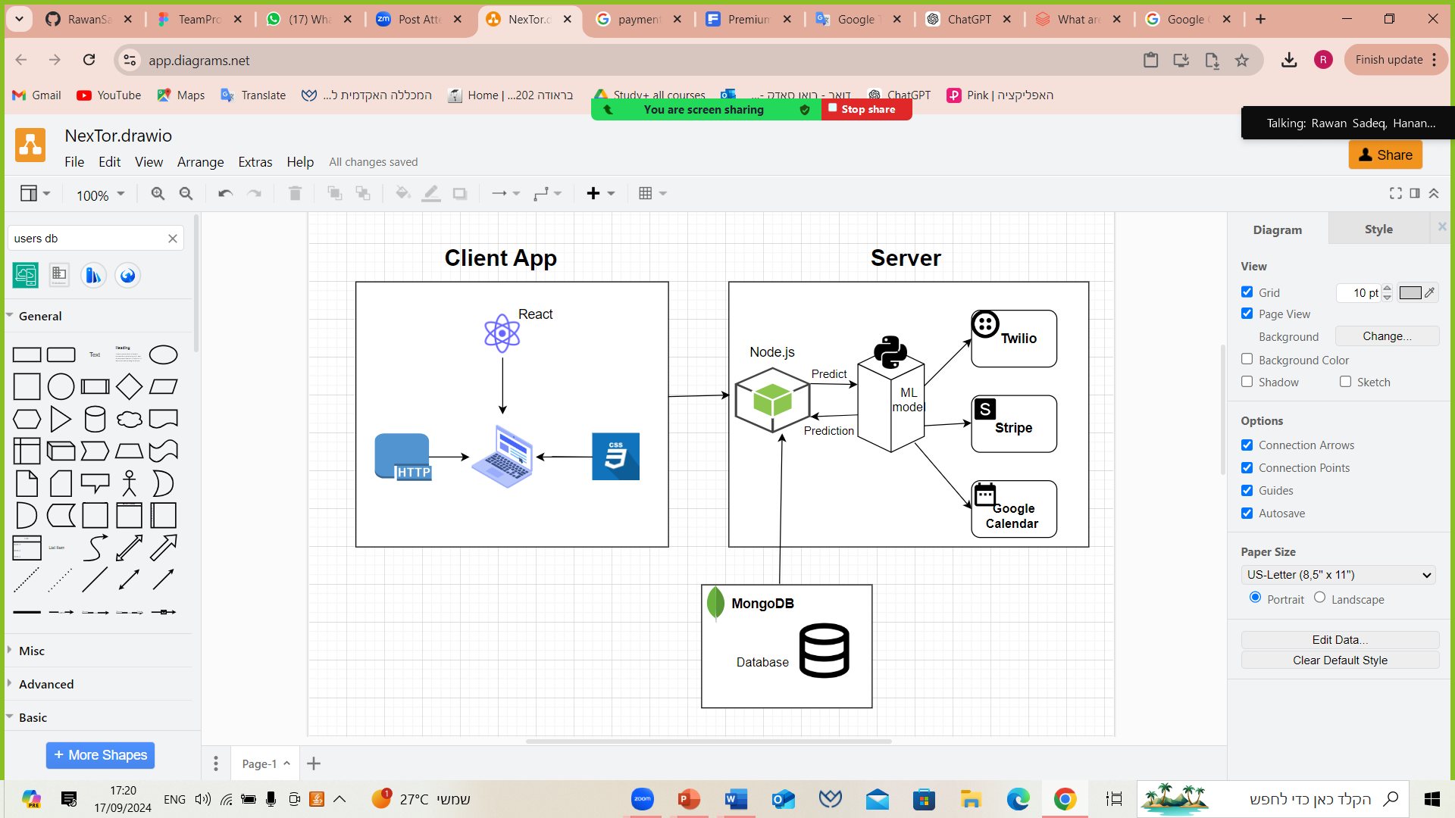

* The Client App (built with React): communicates with the backend Server via HTTP requests.
* The server, running on Node.js, processes these requests. If a prediction or some data from the machine learning model is required, the server calls the ML model, which makes predictions.
* The server also interacts with external services (like Twilio for communication, Stripe for payments, and Google Calendar for scheduling) and stores data in MongoDB as needed.
* Once processed, the server sends the required response back to the Client App, completing the request cycle.

This architecture is a common setup for a modern web application with machine learning and payment processing features, enabling easy communication between the client and various backend services.

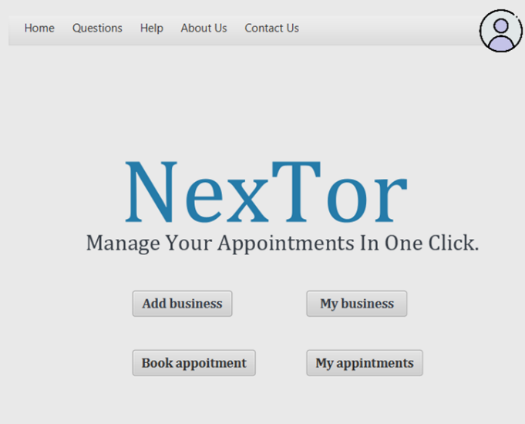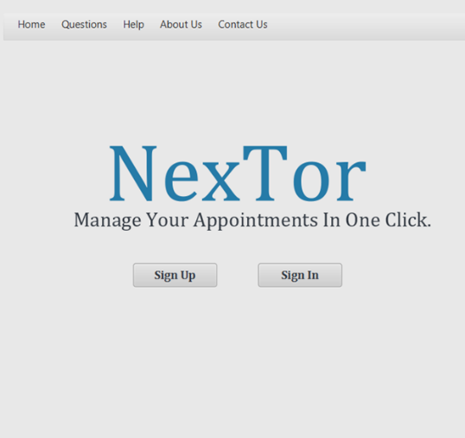**GUI-Graphic User Interface**

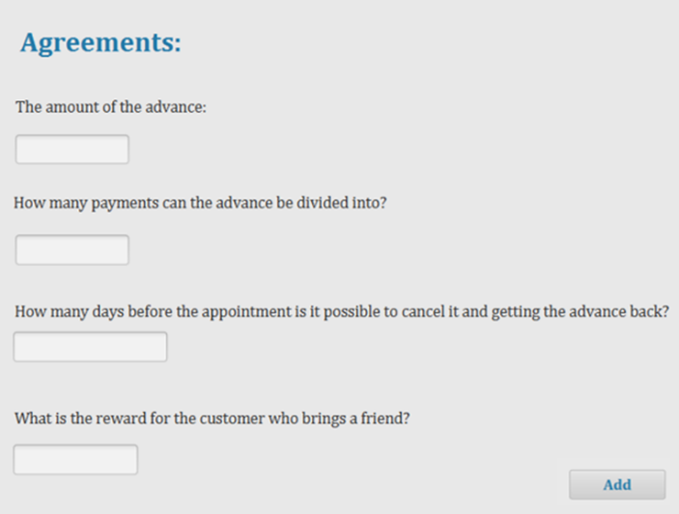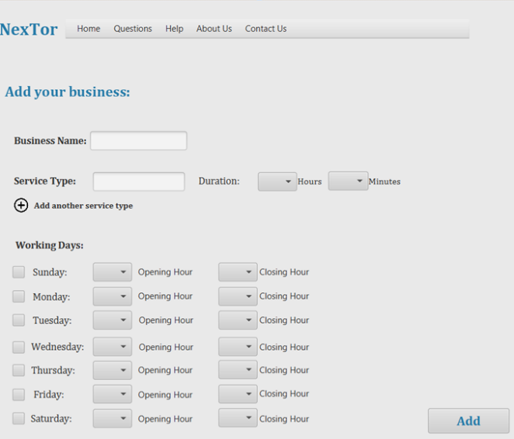

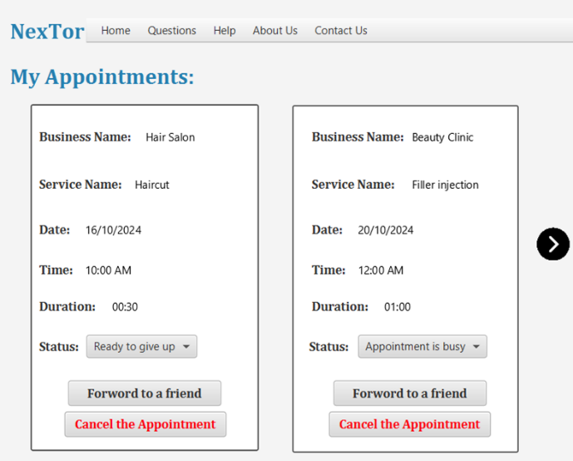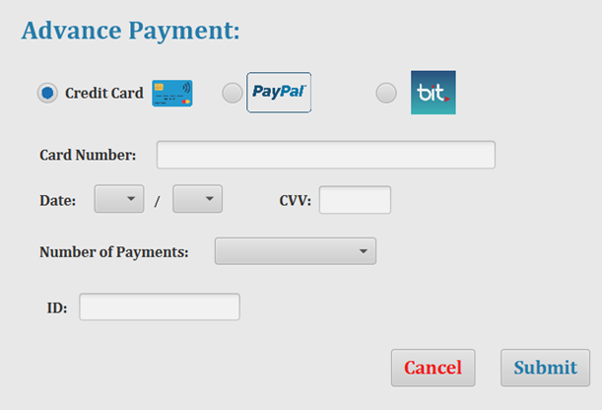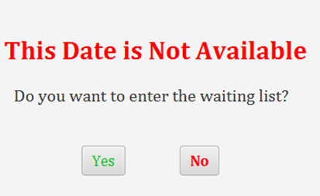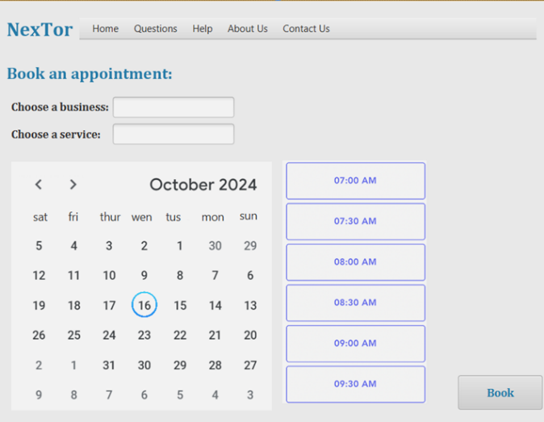

**Testing**

Testing is a critical phase of the development process, ensuring the platform meets its functional requirements and performs efficiently under various conditions. The testing strategy for the "Booking an Appointment with Advance Payment" platform will cover unit testing, integration testing, end-to-end testing, performance testing, and user acceptance testing.

|  |  |  |
| --- | --- | --- |
| **No.** | **Test** | **Expected Result** |
| **1** | Test user registration with valid data. | User account is successfully created, and a confirmation email is sent. |
| **2** | Test login with correct email and password. | User successfully logs in and is redirected to the dashboard. |
| **3** | Test login with incorrect email or password. | User receives an error message, and login fails. |
| **4** | Test booking an appointment. | Appointment is successfully booked, and the customer receives a confirmation SMS. |
| **5** | Test successful payment using Stripe. | Payment is processed, payment status is updated to "successful", and a digital receipt is sent to the customer. |
| **6** | Test payment failure due to insufficient funds or invalid card details. | Payment fails, an error message is displayed. |
| **7** | Test transferring an appointment to another user. | Appointment is successfully transferred, and the new customer receives a confirmation message. |
| **8** | Test sending reminder SMS before an appointment. | Customer receives an appointment reminder via SMS as scheduled. |
| **9** | Test what happens if a customer does not show up for an appointment. | appointment is marked as "no-show", and the prepayment is not refunded to the customer. |
| **10** | Test adding a customer to the waiting list for unavailable date. | Customer is successfully added to the waitlist, and is notified if an appointment becomes available. |
| **11** | Test referring a friend to book an appointment. | The referral is successfully recorded, and the referrer receives a reward after the friend books an appointment. |
| **12** | Test business owner updating their availability appointments. | Business owner successfully updates the available time slots for services, and customers can see the updated schedule. |
| **13** | Test the platform on different browsers. | The platform works consistently across all major browsers (Chrome, Firefox, Safari, Edge). |
| **14** | Test the platform on different devices (desktop, tablet, mobile). | The platform is fully functional and responsive on various devices, with no issues in usability or layout. |
| **15** | Test dividing the advance payment into multiple installments. | The system allows multiple payments (up to the specified limit), and the payment status is tracked accordingly. |
| **16** | Test customer managing their appointments 24/7. | Customers can view, reschedule, or cancel their appointments within the allowed time frame, with updated notifications sent. |
| **17** | Test sending notifications to customers on the waiting list. | Customers on the waitlist are notified if an appointment becomes available, and they can book the slot. |
| **18** | Test consistent updating of customer and appointment data across the system. | Customer and appointment data are updated consistently across all relevant collections (users, appointments, payments). |

**References**

* [https://www.tor4you.co.il](https://www.tor4you.co.il/index.asp?#wt_wrapper)
* <https://www.pinkapp.co.il>
* <https://www.lucidchart.com/pages/uml-activity-diagram>
* <https://www.lucidchart.com/blog/how-to-draw-architectural-diagrams>
* <https://www.altexsoft.com/blog/non-functional-requirements/>
* <https://www.salesforce.com/eu/learning-centre/crm/crm-systems/>
* <https://www.qable.io/blog/comprehensive-guide-to-crm-testing\>